Student Performance Prediction System

Project Id: 27

Name : Nidhi Bhatt
Class Roll Number: 57
University Roll Number : 2028781
Section and Group: K G2

Name : Devashish Chauhan
Class Roll Number: 46
University Roll Number : 2028705
Section and Group: K G2

TABLE OF CONTENTS
- Problem Description 3
  - Dataset Description 3
  - Flow diagram 4
- Modules for Project Implementation…………………..…………………………5
  - Modules Used 5
  - Platform Used 6
- Machine Learning model/ Searching Technique used 7
- Evaluation metrics used 8
- Results and Visualizations 9
- Conclusion and Future Scope 11
- References 12

- Problem Description

This project focuses on predicting student academic performance using Machine Learning techniques by analyzing factors such as study hours, attendance, parental involvement, and access to resources. The dataset was preprocessed through missing value handling, encoding, and feature selection to improve model performance. Multiple models including Linear Regression, K-Nearest Neighbors (KNN), Support Vector Regression (SVR), and Logistic Regression were implemented and evaluated. The system predicts students’ exam scores, pass/fail status, and risk levels, helping educational institutions identify academically weak students at an early stage and support data-driven academic decision-making.

Dataset Description

The dataset used in this project contains information about various academic and non-academic factors that influence student performance. It includes features such as study hours, attendance, parental involvement, motivation level, teacher quality, family income, access to resources, internet access, and physical activity. The main target variable used for prediction is Exam_Score, which represents the marks obtained by students in examinations. Additionally, a Pass_Fail category was created based on exam scores to perform classification tasks.

Before training the machine learning models, the dataset underwent several preprocessing steps, including handling missing values, encoding categorical variables using one-hot encoding, and converting boolean values into numerical form. Correlation analysis and feature selection techniques were also applied to identify the most important factors affecting student performance. Finally, the processed dataset was divided into training and testing sets to evaluate and compare the performance of different machine learning models.

1.2 Flow Diagram
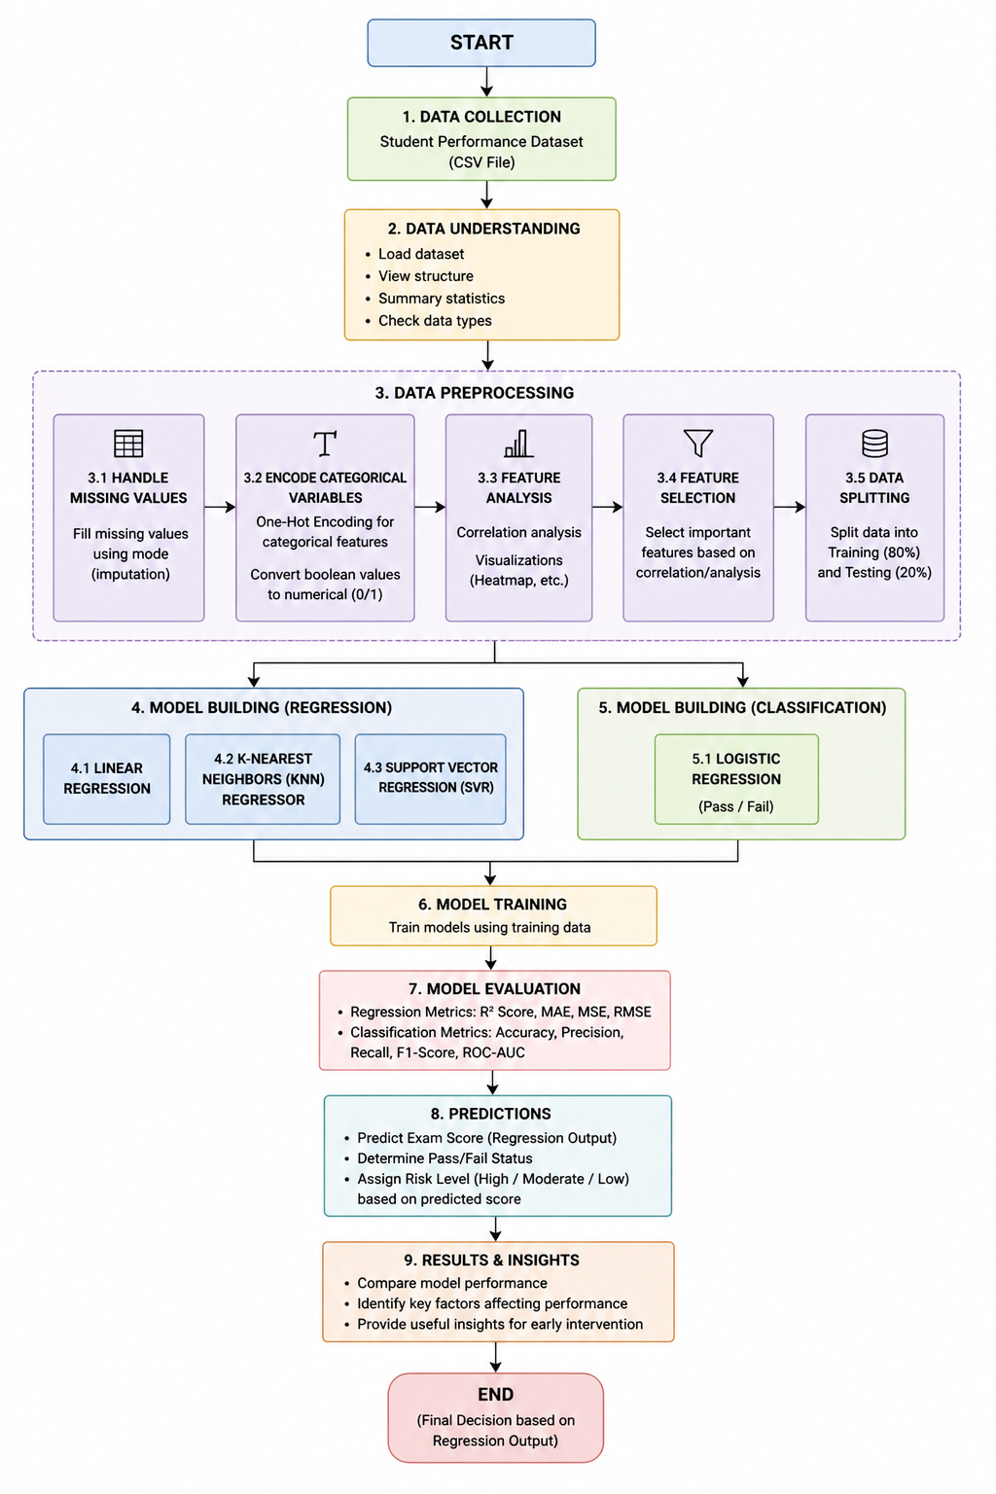

Fig.1 Workflow of Student Performance Prediction System

2. Modules for Project Implementation

1. Pandas
Pandas module has been used for data manipulation, preprocessing, and analysis of the dataset.
Functions Used:
- pd.read_csv() – To read the CSV dataset into a Pandas DataFrame.
- df.head() – To display the first few rows of the dataset.
- df.info() – To display dataset information such as data types and non-null values.
- df.isnull() – To check missing values in the dataset.
- df.fillna() – To fill missing values using mode imputation.
- pd.get_dummies() – To perform one-hot encoding of categorical variables.
- df.corr() – To calculate correlation between features.
- pd.Series() – To create feature importance series.

2. NumPy
NumPy module has been used for numerical operations and array handling.
Functions Used:
- np.full_like() – To create baseline prediction values.
- np.sqrt() – To calculate square root while computing RMSE.

3. Matplotlib
Matplotlib module has been used for data visualization and plotting graphs.
Functions Used:
- plt.hist() – To create histogram plots.
- plt.scatter() – To create scatter plots.
- plt.figure() – To create figure canvas for plots.
- plt.xlabel() – To label x-axis.
- plt.ylabel() – To label y-axis.
- plt.title() – To provide title to plots.
- plt.show() – To display plots.
- plt.axhline() – To draw horizontal reference line in residual plots.
- plot(kind='bar') – To create bar charts for feature importance.
4. Seaborn
Seaborn module has been used for advanced statistical visualization.
Functions Used:
- sns.scatterplot() – To create scatter plots.
- sns.boxplot() – To create box plots.
- sns.heatmap() – To visualize correlation matrices and confusion matrix.

5. Scikit-learn (sklearn)
Scikit-learn module has been used for machine learning model training, preprocessing, feature selection, model evaluation, and pipeline creation.

a) sklearn.model_selection
Used for splitting data and hyperparameter tuning.
Functions Used:
- train_test_split() – To divide dataset into training and testing sets.
- GridSearchCV() – To perform hyperparameter tuning using cross-validation.

b) sklearn.ensemble
Used for ensemble learning methods.
Functions Used:
- RandomForestRegressor() – To calculate feature importance and perform feature selection.

c) sklearn.feature_selection
Used for selecting important features.
Functions Used:
- SelectFromModel() – To automatically select important features from trained model.

d) sklearn.pipeline
Used for creating machine learning pipelines.
Functions Used:
- Pipeline() – To combine preprocessing, feature selection, and model training into a single workflow.

e) sklearn.preprocessing
Used for data scaling and normalization.
Functions Used:
- MinMaxScaler() – To scale feature values between 0 and 1.

f) sklearn.linear_model
Used for regression and classification models.
Functions Used:
- LinearRegression() – To perform regression for exam score prediction.
- LogisticRegression() – To perform classification for Pass/Fail prediction.

g) sklearn.neighbors
Used for nearest-neighbor based learning.
Functions Used:
- KNeighborsRegressor() – To predict scores based on nearest neighboring students.

h) sklearn.svm
Used for Support Vector Machine models.
Functions Used:
- SVR() – To perform Support Vector Regression for score prediction.

i) sklearn.metrics
Used for model evaluation and performance measurement.
Functions Used:
- r2_score() – To calculate R² score.
- mean_absolute_error() – To calculate Mean Absolute Error (MAE).
- mean_squared_error() – To calculate Mean Squared Error (MSE).
- accuracy_score() – To calculate classification accuracy.
- precision_score() – To calculate precision.
- recall_score() – To calculate recall.
- f1_score() – To calculate F1-score.
- confusion_matrix() – To generate confusion matrix.
- roc_curve() – To generate ROC curve.
- roc_auc_score() – To calculate ROC-AUC score.

6. Pickle
Pickle module has been used for model serialization and saving trained models.
Functions Used:
- pickle.dump() – To save trained models and feature columns into .pkl files.
- pickle.load() – To load saved models for prediction.

Platform Used:

• Visual Studio Code (VS Code)
Visual Studio Code was used for writing, editing, testing, and debugging the Python scripts used in the project. It provides an efficient development environment with features such as syntax highlighting, IntelliSense, debugging support, and extension integration, which improved overall coding productivity and project management.

• Jupyter Notebook
Jupyter Notebook was used for data analysis, visualization, model training, and experimentation. It allows step-by-step code execution, making it easier to analyze outputs, visualize graphs, and test machine learning models interactively.

• Python
Python was used as the primary programming language for implementing the machine learning models and data preprocessing tasks. Python provides extensive libraries for data analysis, visualization, and machine learning, making it suitable for developing predictive systems.

• Pandas Library
Pandas was used for data manipulation and preprocessing tasks such as handling missing values, encoding data, and organizing datasets into DataFrames for analysis.

• NumPy Library
NumPy was used for numerical computations, mathematical operations, and array handling during preprocessing and model evaluation.

• Matplotlib and Seaborn
Matplotlib and Seaborn libraries were used for data visualization. These libraries helped generate histograms, scatter plots, box plots, heatmaps, confusion matrices, and ROC curves for exploratory data analysis and result interpretation.

• Scikit-learn (sklearn)
Scikit-learn was used for implementing machine learning algorithms, feature selection, model training, hyperparameter tuning, evaluation metrics, and pipeline creation. It provided efficient tools for regression and classification tasks.

• Pickle
Pickle was used for saving and loading trained machine learning models and preprocessing information. This allowed the trained models to be reused for prediction without retraining.

3. Machine Learning Model/ Searching Technique Used
1. Linear Regression
Linear Regression is a supervised learning algorithm used to predict continuous numerical values. In this project, it was used to predict students’ exam scores based on different academic and non-academic factors. It provided the best overall performance among the tested models.

2. K-Nearest Neighbors (KNN Regressor)
KNN Regressor predicts values based on the similarity between data points. It identifies the nearest neighboring students and predicts scores using their data. This model was used for performance comparison with other regression models.

3. Support Vector Regression (SVR)
Support Vector Regression is used for predicting continuous values while handling non-linear relationships in the data. In this project, SVR was used to improve prediction performance on complex patterns within the dataset.

4. Logistic Regression
Logistic Regression is a classification algorithm used for binary classification problems. In this project, it was used to classify students into Pass or Fail categories based on their performance.

5. Random Forest Regressor
Random Forest Regressor is an ensemble learning algorithm that combines multiple decision trees. In this project, it was mainly used for feature importance analysis and feature selection.

6. GridSearchCVGridSearchCV is a hyperparameter tuning technique used to find the best parameter values for machine learning models through cross-validation. It was used to optimize KNN and SVR models.

7. Feature Selection Technique
Feature selection techniques such as correlation analysis and Random Forest feature importance were used to identify the most important features affecting student performance.

8. Pipeline Technique
Pipeline was used to combine preprocessing, scaling, feature selection, and model training into a single workflow for consistent and efficient model execution.

4. Evaluation metrics used

A. Regression Metrics
These metrics were used to evaluate how accurately the models predict the exam score.

1. R² Score (Coefficient of Determination)
Formula:
$$R^{2}=1-\frac{∑(y_{true}-y_{pred})^{2}}{∑(y_{true}-y_{mean})^{2}}$$
Description:
R² measures the proportion of variance in the dependent variable that is explained by the independent variables in the model.
Interpretation:
- $R^{2}=1$: Perfect fit
- $R^{2}=0$: Model does not explain the data
- $R^{2}<0$: Model performs worse than baseline

2. Mean Absolute Error (MAE)
Formula:
$$MAE=\frac{1}{n}∑∣y_{true}-y_{pred}∣$$
Description:
MAE calculates the average absolute difference between the predicted and actual values. It provides a straightforward measure of prediction error.
Interpretation:
A lower MAE indicates better model performance.

3. Root Mean Squared Error (RMSE)
Formula:
$$RMSE=\sqrt{\frac{1}{n}∑(y_{true}-y_{pred})^{2}}$$
Description:
RMSE measures the square root of the average squared differences between predicted and actual values. It penalizes larger errors more heavily than MAE.
Interpretation:
Lower RMSE values indicate better model accuracy, especially when large errors are undesirable.

B. Classification Metrics
These metrics were used to evaluate the performance of the pass/fail classification model.

1. Accuracy
Formula:
$$Accuracy=\frac{TP+TN}{TP+TN+FP+FN}$$
Description:
Accuracy measures the proportion of correct predictions made by the model out of all predictions.
2. Precision
Formula:
$$Precision=\frac{TP}{TP+FP}$$
Description:
Precision indicates how many of the predicted positive cases (Pass) are actually correct.

3. Recall
Formula:
$$Recall=\frac{TP}{TP+FN}$$
Description:
Recall measures how many actual positive cases were correctly identified by the model.
4. F1 Score
Formula:
$$F1=2×\frac{Precision×Recall}{Precision+Recall}$$
Description:
F1 Score is the harmonic mean of precision and recall, providing a balance between the two.

5. ROC Curve and AUC Score
Formula (Key Components):
$$TPR=\frac{TP}{TP+FN},FPR=\frac{FP}{FP+TN}$$
Description:
The ROC curve represents the trade-off between True Positive Rate and False Positive Rate at different thresholds. The Area Under the Curve (AUC) summarizes the model’s ability to distinguish between classes.
Interpretation:
- AUC = 1 → Excellent performance
- AUC = 0.5 → No discrimination

5. Results and Visualizations

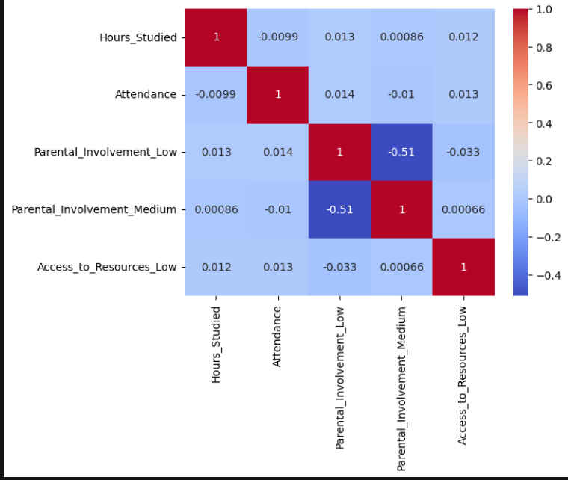

Fig. Heatmap showing corelation.

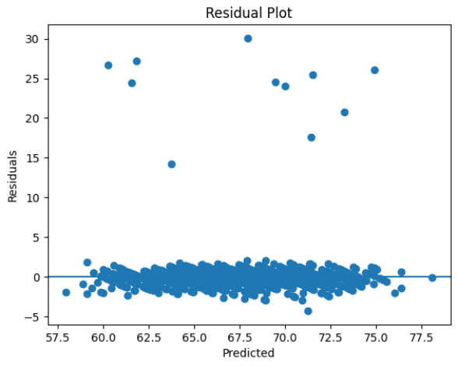
Fig. Residual plot

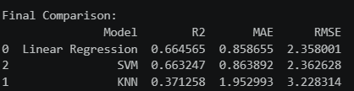
Fig. Comparison between models

6. Conclusion and Future Scope:

Conclusion
The heatmap visualization helped in understanding the relationship between different features present in the dataset. By using correlation analysis, it became easier to identify positively and negatively related attributes. The project successfully demonstrated how data visualization techniques can simplify complex datasets and support better decision-making in machine learning and data analysis tasks. The implementation using Python libraries such as NumPy, Pandas, Matplotlib, and Seaborn provided accurate and efficient results.
Future Scope
The project can be further improved by applying advanced visualization techniques and machine learning algorithms on larger and more complex datasets. Interactive dashboards can also be developed using tools like Plotly and Tableau for better user experience. In future, the system may be integrated with real-time data analysis and predictive models to provide deeper insights and more accurate outcomes.

7. References:
Books:
1 Hands-On Machine Learning with Scikit-Learn, Keras, and TensorFlow – Aurélien Géron
2 Python for Data Analysis – Wes McKinney
3 Introduction to Machine Learning with Python – Andreas C. Müller & Sarah
GuidoOnline Resources:
GeeksforGeeks – https://www.geeksforgeeks.org/
Scikit-learn Documentation – https://scikit-learn.org/
Pandas Documentation – https://pandas.pydata.org/
NumPy Documentation – https://numpy.org/
Matplotlib Documentation – https://matplotlib.org/
Seaborn Documentation – https://seaborn.pydata.org/
Stack Overflow – https://stackoverflow.com/
Kaggle – https://www.kaggle.com/
Jupyter Documentation – https://jupyter.org/
Python Official Documentation – https://docs.python.org/3/

